**Worx Landroid package for Home Assistant**

Worx Landroid package for Home Assistant based on [Landroid Cloud by @MTrab](https://github.com/MTrab/landroid_cloud)

First install Landroid_cloud from HACS

Then do this setup!  
<https://github.com/Barma-lej/halandroid> (this is this guide)

[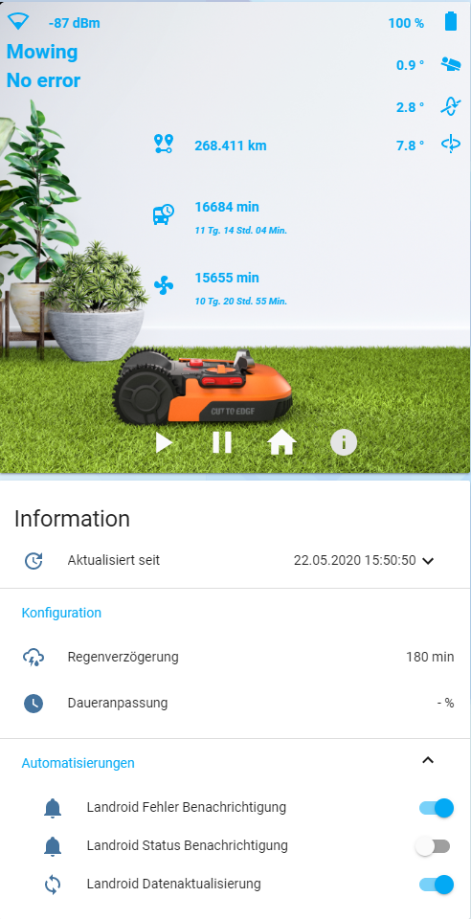](https://github.com/Barma-lej/halandroid/blob/master/media/halandroid20200522.png)

**Requirements**

1. **Home Assistant** version 2021.4 or above
2. **Landroid Cloud** Integration. Install [using HACS](https://github.com/hacs/integration) or [see this guide](https://github.com/MTrab/landroid_cloud#installation)
3. **fold-entity-row** plugin. Install [using HACS](https://github.com/hacs/integration) or [see this guide](https://github.com/thomasloven/lovelace-fold-entity-row#installing)

**Installation**

1. In configuration.yaml add string *packages: !include_dir_named packages*:

homeassistant:

packages: !include_dir_named packages

1. Edit your secrets.yaml.

landroid_mail: YOUR_EMAIL_IN_MY_LANDROID

landroid_pass: YOUR_PASSWORD_IN_MY_LANDROID

landroid_ip: YOUR_LANDROID_IP_ADDRESS_IF_YOU_NEED_IT_OR_''

landroid_sn: LANDROID_SERIAL_NUMBER_IF_YOU_NEED_IT_OR_''

landroid_mac: LANDROID_MAC_ADDRESS_IF_YOU_NEED_IT_OR_''

1. Copy folders **www** and **packages** with all content in your homeassistant folder
2. If you need different as English language (Current is only in German) then add to folder **package** a file with your language from a folder *lang/landroid_LANGUAGE_CODE.yaml* e.g. [lang/landroid_de.yaml](https://github.com/Barma-lej/halandroid/blob/master/lang/landroid_de.yaml).
3. Create a new manual card in Lovelace ([Here is manual](https://github.com/Barma-lej/halandroid/blob/master/help/add_card.md)) and add content from a file [lovelace/card.yaml](https://github.com/Barma-lej/halandroid/blob/master/lovelace/card.yaml). If you need different as English language then add content from a file *lovelace/card_LANGUAGE_CODE.yaml* e.g. [lovelace/card_de.yaml](https://github.com/Barma-lej/halandroid/blob/master/lovelace/card_de.yaml).
4. Change the name of lawnmower in App to **Mower**

OR

Search sensor.landroid_mower_battery, sensor.landroid_mower_error, sensor.landroid_mower_status in the files **package/landroid_de.yaml**, **package/landroid_LANGUAGE_CODE.yaml** and in **new Lovelace card** and replace it with your sensor names

1. If you use a Google Assistant, then use switch **landroid_mowing** in your Google Assistant integration:

switch.landroid_mowing:

name: Mähroboter

room: Garten

expose: true

1. Check config and restart Home Assistant

***Enjoy***

**If your lawnmower has been banned.**

Services and app stopped working

* Go to [My Landroids](https://account.worxlandroid.com/product-items)
* Unlink your Landroid
* Open app on mobile device
* Add Landroid